Elizabethan Ruff Construction – Costume College 2021

Instructor: Jennifer F. Erlichman
Modern Setting Techniques by Christina Forst
PayPal Donation Link: jerlic@yahoo.com

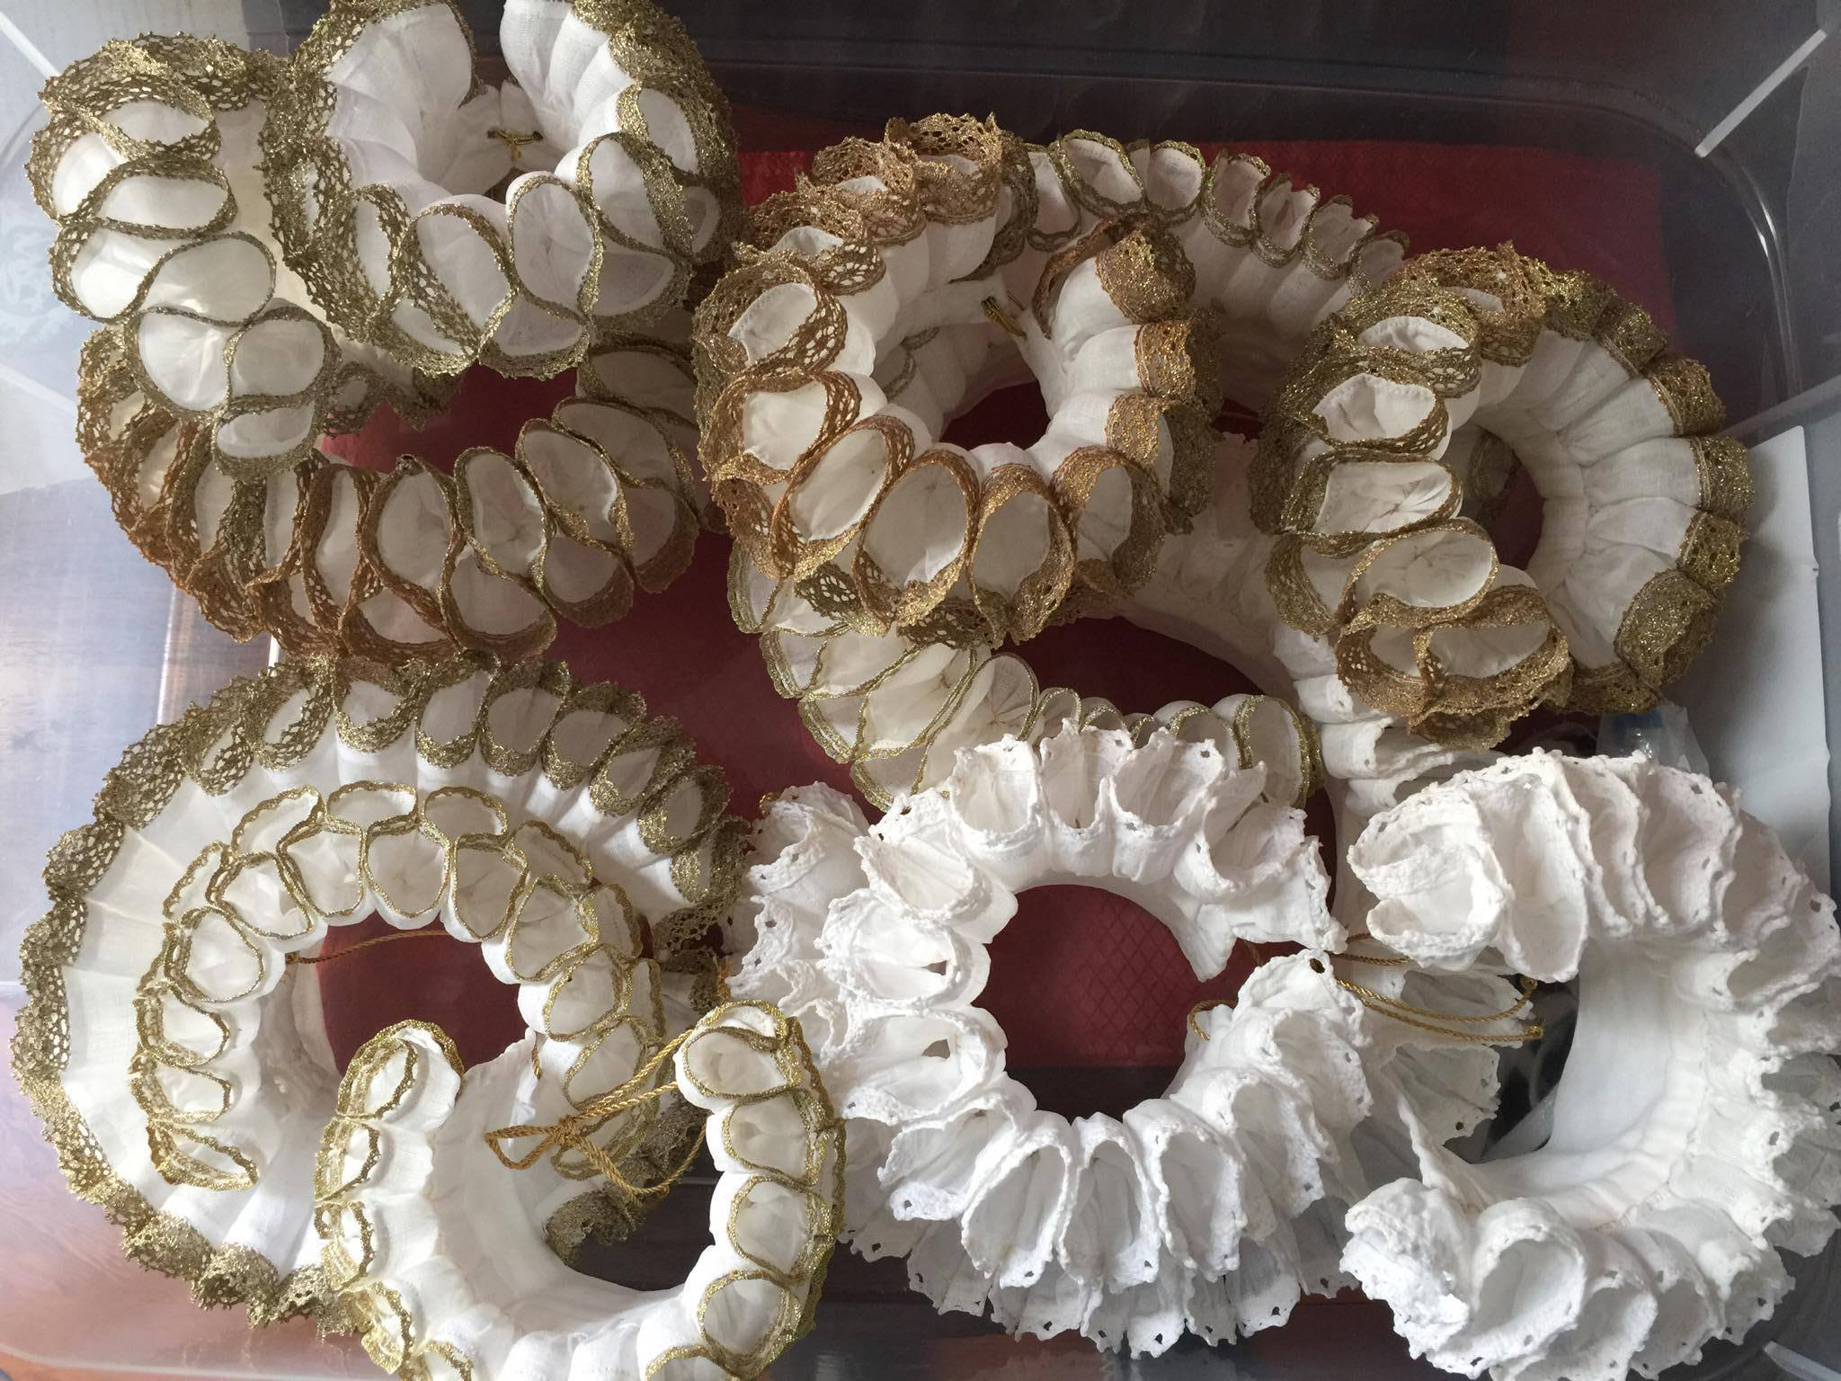

This document is an adaptation and continuation of Noel Gieleghem’s original ruff 42-page ruff tutorial, which includes color photos and more in-depth descriptions of all the techniques discussed here. For all ruff documents, go to:

https://www.guildofsaintgeorge.com/ruff-resources

In this class, we are going to focus on the ideal "starter" ruff, a 1570s-style stand-alone linen ruff of moderate fullness and moderate depth. Stand-alone ruffs, partlets with ruffles, and shirt and chemise collars with attached ruffles all coexisted at the same time. There is evidence that ruffs were part of what might be called “Elizabethan ready-to-wear”, and were purchased ready-made. This form of “conspicuous” fashion consumption required regular maintenance, and there were businesses dedicated to cleaning, starching, and setting ruffs.

Introduction

The basic parts of a ruff are:

Ruffle - the outside edge of the ruff that is ironed into Setts.

Setts - figure eight pleats that are set to create the ruff.

Neckband - the part of the ruff which closes around the wearer's neck.

Making the Ruff

These directions create a custom-fitted ruff to fit a 15" neck. Elizabethan ruff makers seem to have used a rather fluid formula to calculate the amount of fabric required for the ruffle. Various sources have suggested about 12” of ruffle per 1” of neckband. You will gather and test your ruffle before adding the neckband to check the fit.

Fabric - Depending on the size and density, each neck ruff will require about 1/4 to 1/2 a yard of linen. To start, you’ll need a 3" wide 150"-200" strip of 2.8-ounce to 3-ounce per yard even weave handkerchief-weight linen. You're after the finest, most tightly woven fabric you can find. Fabrics of this quality range from $12 - $80 per yard. Be wary of Chinese linen (woven from very short staple fiber and prone to wrinkling). Irish, German, and Italian linens seem to be the best choices on the market today. It's always best to get a sample first before buying.

As strange as it sounds, the finest linen and most expensive linen we can find today would probably have been considered of average quality by an Elizabethan, so even if you're making a ruff for a lower or middle-class character, you'd be hard pressed to find linen which was too "good." Modern fabric just isn’t made as dense or as finely-woven.

The linen you choose should have a good, tightly-woven selvage with a clean-finished edge. If it's fuzzy, trim the edge to make it look neat. If the selvage on your fabric is compromised or missing, you will need to address this issue when you join the strips together.

Thread - 100% cotton thread is the best choice for constructing both the ruffle and neckband by hand. Linen thread tends to snarl. Use bleached beeswax rather than unbleached, which can leave a yellow residue. Cotton/Poly blend works great for machine sewing.

For gathering the ruffles, use extra-strong thread. Upholstery thread, carpet thread, quilting thread, Gortex, nylon beading thread, and even un-waxed dental floss will work.

Lace - If you chose to edge your ruff with lace, you'll need at least 156"-206" (150" + 3" + 3", up to 200” +3” +3”) of period-looking, un-gathered cotton or linen lace. There is a lot of very nice cotton lace coming out of China. Period lace can look a bit rough to our modern eyes, so this coarse Chinese lace reads perfectly. Linen lace is hard to find. Be sure you pay attention to scale, and err on the small side. Lace is optional, but it is strongly recommended for first-time ruff makers as it is a great tool for measuring the setts when it comes time to iron the ruff. Be careful when choosing anything with a color or metal/plastic; be sure to test the colorfastness of all lace, test your hot setting tools on it, and test all lace in OxyClean before starting your ruff.

Neckband Fabric - For this ruff, the 15" x 2" neckband is created from a rectangle of fabric 8" (folded twice to make 2” sides) wide by 16" long. If the neckband is any narrower than 1 1/2", the ruff won’t sit properly under your chin. You can use slightly coarser fabric for this than for the ruffle, as it will be taking more wear and tear, and can easily be replaced when worn.

Closures - Ruffs can be closed with buttons and button holes, hooks and eyes, linen tapes, luceted, braided, or twisted band strings (both attached and/or passed through a worked eyelet), and pins. For ease of wear and maximum adjustability, ruffs which close by means of ties are the best option. Buttons and hooks and eyes are less adjustable. Stand-alone ruffs were also basted or pinned into place at the collar of the outer garment or the collar of a shirt, chemise, or partlet.

Construction

Summary of Steps

1. Wash fabric
2. Iron and cut strips and neckband
3. Join selvages
4. Add lace
5. Mark CB
6. Pleat ruffle
7. Attach neckband
8. Finish closures

Ruffle - Preshrink and wash all of your linen in hot water and press it. Ruffles were almost always created from joined selvage-to-selvage strips of fabric, and this is a very subtle yet very important component of ruff construction. Do not use a strip cut from the length of fabric and/or use the selvage as a finished edge. Strips cut from the length-wise grain collapse into themselves lengthwise and it will be very difficult to get a ruffle created in this manner to "spring" from the neckband properly.

When preparing to cut your fabric, pull a thread from selvage to selvage to find the true grain. Draw the thread, and then cut along this line. Pull the thread using a pin or needle to get it started. Running a bar of soap over the line before removing the thread helps.

Remember that your goal is 150"-200" or so per ruffle, total, and as you're cutting selvage to selvage, the width of your fabric determines the number of strips you'll need to cut. Cut selvage-to-selvage strips of linen 3" wide. A 3" wide strip produces a ruff with a finished depth of about 2 1/2". 150” is on the smaller side, for a smaller neckband. A 200" strip gives you a lot of wiggle room, but it's at the top end of an average ruff of this width.

The method of joining the strips together is in large part determined by the quality of the selvage. If the selvage is tight, make an abutted join. To do this, place the two selvage edges together and whipstitch them using waxed cotton thread, a fine needle, catching the smallest amount of thread possible at the edge of each selvage. Place your whipstitches very close together. If done properly, the join is barely visible from the "right" side. There is a slight ridge on the "wrong" side. If for some reason there is no selvage or if the selvage is uneven, make a flat felled join. Make this join as small as possible. After joining the strips, you can machine zig-zag the raw bottom edge to stop it from unraveling before you pleat the strip. Try to use the least amount of thread possible as it can add bulk.

In period, the raw top edge of the ruffle would have been hemmed by hand and then the lace would have been applied to the hemmed edge. Alternately, in the case of needle lace and/or cutwork, the threads of the raw edge would have been worked into a type of lace. There is some visual evidence of ruffs with barely-finished or raw exterior edges, but this is not the norm. Thankfully, there is a machine alternative. It's a multistep process, but looks good and, if you set your stitch length to very short stitches, it is difficult to see that it has been applied by machine. Apply the bottom edge of your lace to the outside edge of your linen using the smallest hem you can manage. Then flip the lace upward, iron, and topstitch to encase that tiny raw edge under the bottom edge of the lace.

If you chose not to use lace, you can still hand or machine hem the raw edge, but alas, you won’t have the advantage of a built-in measuring tape. Hems of this type should be no wider than 1/8".

If your goal is to make an authentic ruff, resist the temptation to use monofilament fishing line, zigzag stitching, or doubling the fabric. Fishing line introduces a host of issues with heat setting, and doubling the fabric can make it impossible to fit the ruffles into the neckband once pleated. Although we don’t discuss it here, there's excellent information online about how to create a more modern type of ruff. We will cover modern ways of setting an authentic ruff.

Don’t forget to finish the two short ends of the ruffle strip as well with hemming and lace. At this point, find the exact center of the finished, exterior edge of the strip of fabric and mark the center back (CB) using a French knot or bit of embroidery. This mark will be very important when it is time to put the setts into your ruff. Don’t place it within the seam allowance covered by the band.

Gathering/Cartridge Pleating – Now you are ready to gather the long ruffle into regular 1/4" cartridge pleats using a line of two to four parallel rows of gathering stitches. Patterns of Fashion 4 shows two additional techniques, but they are really just slight variations on this theme. No accordion pleats. No stacking. No measuring necessary.

When making the gathering stitches, it is easiest to use a blunt needle (such as a crewel needle) which allows the tip to pass between the threads, rather than splitting them. Leave your heavy-duty thread on the spool and thread your needle. Run your first line of gathering stitches about 1/8" from the unhemmed bottom edge. Run successive lines of gathering threads about 1/4" away from the first line of stitches. Use two to four lines of stitching. If you keep the fabric flat throughout this process, rather than gathering as you go along, it is much easier. Leave a 10" to 12" thread tail on either end.

Constructing the Neckband - Make your neckband bigger than you think you should, as the ruffle is bulky. To find the correct measurement, gather up the ruffle after cartridge pleating and loop it around your neck. Tighten the pleats down enough until you get a snug fit and the fronts don’t quite touch. Measure both the outer circumference, and the inner circumference. The bulk of the gathered ruffle can add up to 2" to your outer neck measurement. You don't want to make the ruff too tight, although you do want it to fit snugly.

For a 15" x 2" finished neckband, start with a rectangle 16" x 8". Fold this rectangle in half, lengthwise, and press. Unfold, and then fold the two long edges toward the center crease line. Press. Your strip will now be 4" wide. Unfold and then fold under 1/2" on each of short ends, towards the inside. Press. Then refold the two long edges down toward the center fold line, and then bring the two long folded over edges together. Your neckband should now be 15" x 2". Press this very well, perhaps using some spray starch to hold the creases. In period, neckbands do not appear to have been curved or shaped.

Attaching the Ruffle to the Neckband - This is definitely a situation in which hand sewing is far superior to machine sewing and will yield a much better result. Divide the ruffle into workable units. If it's constructed of three 60" panels, each unit will be one 60" panel. For a 15" neckband, mark three 5" sections on the neckband. Gather the ruffle to 15" and manipulate the pleats to make sure they're evenly distributed. If you lay it down on a ruler, you should have seams match up to the 5" and 10" marks, with the two edges touching the 0" and 15" mark. Groom the ruffles so that the pleats are nice and straight.

It's very important that this ruffle unit is rock solid as you're not really going to do much more than tack it in place to the neckband. You do not need to machine stitch over the gathered edge, it should hold itself in place. Do not rely on the sewing which is attaching the ruffle to the neckband to hold the gathers in place, as they are just there to hold the neckband on.

Match the three joins of the ruffle to the corresponding marks on the neckband, and lay the long, folded edge of the neckband on top of and parallel to the most interior gathering thread. Baste the neckband in place rather than relying on pins, which get in the way. Working from the center of the neckband to the short ends, whipstitch the folded edge of the neckband to the pleated ruffle. You can space your stitches about 1/4" to 3/8" apart. Make sure the end of the ruffle stops just a trifle shy of the folded under short end of the neckband.
Fold up the other long edge of the neckband and repeat. At this point (and only after you've completed all of your stitching) tie a square knot or two in the pleat gathering threads. Clip them to about 1" and tuck the tails back into the neckband. Finish the short ends by whip stitching closed as close to the edge as you can. Consider your method of closure at this point. Do not trim the seam allowance on the ruffle. The finished edge of the neckband enclosing the ruffle will be quite thick, as you're sandwiching up to 200" of gathered fabric into a 15" neckband. Don't
panic. This is okay. The ridge you create acts a type of fabric boning around the top edge of the ruff, causing the whole thing to remain upright and giving the ruff a huge amount of spring off of the neck.

Extant ruffs often have feather or back stitching on the surface of the neckband, effectively "quilting" the neckband fabric to the ruffle in order to create a solid, unshifting unit, but it isn’t necessary if your pleats are tight.

The final step is to work the button holes, hooks and eyes, tapes, or eyelets.
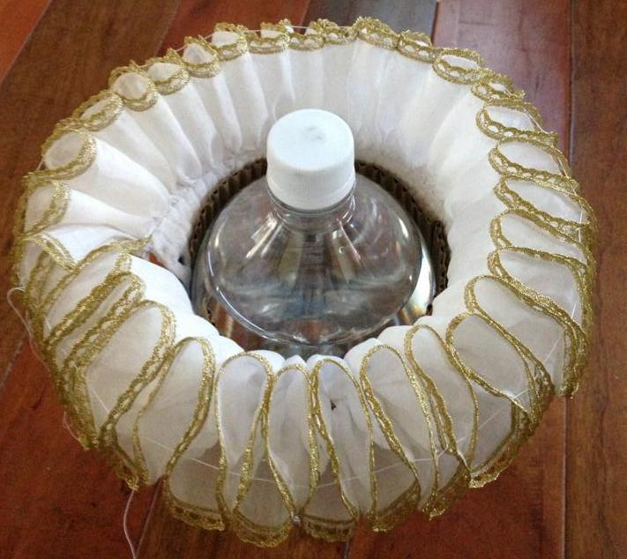

Ruff Maintenance

Washing - For the most part, a ruff's shape is determined by how it is ironed, rather than how it was constructed. Ruffs require regular washing, re-starching, and resetting, as an authentically-created ruff will collapse when it gets dirty or moist from wear. The starch will hold the dirt, and when it dissolves, the linen should clean quite easily.

Wash linen ruffs in hot water to dissolve the old starch. Always use non-chlorine bleach (like OxyClean), as bleach can damage the linen fibers, and test samples first! Wash ruffs with delicate lace by hand ONLY; more robust ruffs can handle gentle machine washing in lingerie bags. Scrub stubborn stains gently with a toothbrush after pre-soaking in detergent and OxyClean. Blot the ruff dry by gently rolling it in a towel. Never “wring” or twist wet linen.

Starching - There are two historical starching techniques, one using "cold" starch, and the other using boiled starch. Cold starch involves dissolving raw starch in water and then applying it to the fabric. The starch is "cooked" (gelatinized) when the cloth is ironed. This produces the stiffest finish, but requires a very skilled hand in order to not scorch the fabric brown, or end up with the cloth stuck to the iron.

When you boil raw starch, it thickens into a transparent "jelly." You can work this jelly into the damp linen, allow it to dry completely, remoisten it very slightly with a spray bottle, and then iron it without fear of sticking or scorching. This is the best method.

Many historical recipes recommended adding paraffin, spermaceti, borax, or salt to boiled starch, but none of it is necessary. Nowadays boiled laundry starch is difficult to come but it's really unnecessary as cornstarch is readily available (and that's what American laundry starch is made from anyway). Unfortunately, cornstarch is prone to yellowing and does not give the crispest finish. The Elizabethan starch-of-choice was wheat and, to a much lesser degree, rice starch, which provides the stiffest set. Both wheat and rice starch are available from bookbinders (see Appendix for sources).

A good basic recipe is:

2 tablespoon raw starch (corn, wheat, rice. . . my favorite is ½ wheat with ½ rice)
1 cup cold water

Whisk the starch in a heat-safe glass bowl with a little cold water to form a paste, and then add the remainder of the water. Either microwave in 30-second cycles on "High", whisking thoroughly between heating, or heat the mixture on the stove, stirring constantly, until it becomes thick and transparent, with little bubbles mixed in. This proportion will make a fairly stiff starch "jelly." You want to try and avoid chunks forming as it cooks by stirring often.

Spray starch works, and can be useful for touchups, but it's a very expensive way to starch a ruff.
Sta-Flo (a pre-made, blued, liquid cornstarch product) is okay, although it's not quite thick enough and the bluing has caused problems with Procion black dye, causing it to bleed red. For this reason, if you chose Sta-Flo, buy the variety with contains no colorants. In period, the starch was often lightly tinted blue, yellow, pink, or green.

Starch should be applied to damp, not dry, linen so that it can fully penetrate the fibers. If you have hung up your washed ruffs to dry, a quick spray with water will get them ready for starch. Pour some hot starch “jelly” into another heat-safe glass bowl, and add the slightly damp ruff. Work the starch thoroughly into all of the folds. Gently "squeegee" out the excess starch, but make sure you leave a relatively thick coating. In the Elizabethan era, starch was expensive; we can be more generous as starch is now cheap.

Lay the starched ruff out to dry, smoothing the folds, and finger pressing out any wrinkles. A great method is to hang them on hangers with clothes pins. Finger training the ruff at this point is a good idea if you have already basted the setts. After starching, you must let the ruff dry completely. It's a good idea to open the pleats up as the ruff is drying so that they do not stick together. Setts which are glued together with starch can lead to torn fabric when you try to pry them apart. Patched and darned ruffs were quite common, but you can avoid this if you pay attention during the drying process.

Setting

Poking Sticks & Curling Irons – The ideal criteria for a curling iron should be one with a removable plastic tip and clip (the thing which holds the hair against the heated rod), or ideally one in a “bullet” shape without a tip. You’ll need a variety of sizes, from ½’ to 1 ½’ typically. The curling irons with removed tips form a "valley" at the gathered neck edge of the ruff where the tip cannot reach, so you may need to find some way of pushing those pieces of linen outward.

Basting the Setts – Before you start to set your ruff, you’ll need to determine what you'd like your setts to look like. A great guide is a cold curling iron. Once you’ve determined the amount of fabric required for a sett, you need to start at the center back (CB) of the ruff (the exact center should be marked), and start marking from there. You can either use the repeats in the lace, the repeats in the weave of the fabric, a ruler and a washable marking pen, or pins. Baste the setts in place, using cotton or nylon thread, running the thread right through the center of each S-curve is through either the lace or the fabric. You can baste before you wash, after you wash, or after you starch.

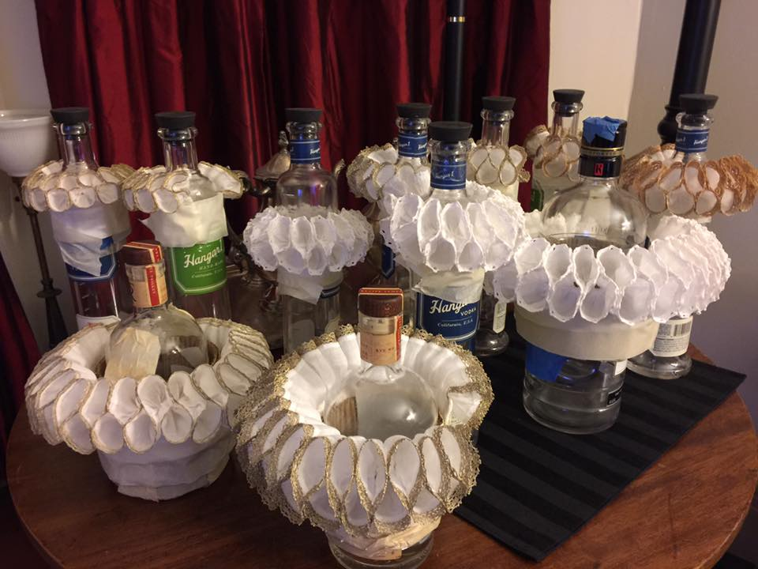

Ironing - You will need to use a regular steam iron to press the neckband before you iron the ruffles. Lightly dampen the ruffle, using a spray bottle filled with water. You want the ruffle to be just ever so slightly damp. Do not dampen the neckband. Mount the ruff on a “ruff stand” (can be a piece of weighted foam, something you can masking tape the ruff to, or even a glass bottle filled with water, as long as it is heavy enough not to fall over) and fasten it.

The linen will iron up quite nicely even it if feels dry to the touch. Linen can hold a
tremendous amount of water without feeling damp. The damper the ruff is, the longer it takes to iron and the more the un-ironed damp sections will wick water into the ironed sections, undoing all of your hard work. Less is more when it comes to spraying

Heat your curling iron to “High”. Starting at the CB, grasp each sett where the basting thread passes through the "waist" of the sett. Push the iron into the sett, pinching at the basting thread, and gently force the iron into the pleat. It will un-wrinkle and become rounded. Go to the next pleat, on the same side (top or bottom) and repeat the process. Continue until all the setts are ironed. Undo the ruff and flip it over. Repeat the process. The last two setts at left front and right front might need to be finessed as they often end up a size different from the preceding sett. You can cheat backwards a few setts in each direction to make the setts gradually smaller, but it isn't really necessary, and slight unevenness wasn't an issue if you look at the portraits.

When the ruff is completely dry, pull the basting thread up tight to secure the ruff and hold the setts until the ruff is completely dry. This is also a good way to store and travel with a ruff. You can also reinsert the basting thread before washing if you like a particular sett, or make notes as to the repeat sequence. The basting thread is really a crutch to make sure the setts are all equal. It is not authentic. Someone who washed and ironed ruffs for a living could probably eyeball a sett. Another way to ensure that your setts stay perfect is to tack each sett down with thread. This will be critical for our next section on Modern Techniques.

When it comes to starched ruffs, moisture is your worst enemy. Keep the basting string in
place until the last possible moment. Realize, however, that the natural "decay" which a ruff will experience over the course of a long, sweaty day is part of an authentic ruff's charm, as are unruly setts and the fussing they require. By all means incorporate these facts into what you're doing as a performer and fiddle with your ruff (or have someone fiddle with it for you). All of this was well documented by contemporary sources, and can be seen in portraits.

Modern Techniques/Alternate Ruff Setting Methods aka “How to Cheat”

So now that you have seen what was historically done, you are probably wondering how to improve upon this method and make it faster and more efficient. Don’t worry, it’s possible, and also works very well.

Pros: Faster Cons: Not as stiff as traditional cooked starch
Foolproof! Not historically accurate
No Heat – Looks Great Cannot change sett size easily
You
need: A completed ruff
Foam curlers
Heavy spray starch
Needle and thread

Take your completed neck ruff and choose a curler based on the size of setts you prefer and the amount of fabric in your ruff. A larger curler will result in fewer, larger setts; smaller rollers will make smaller, tighter setts.

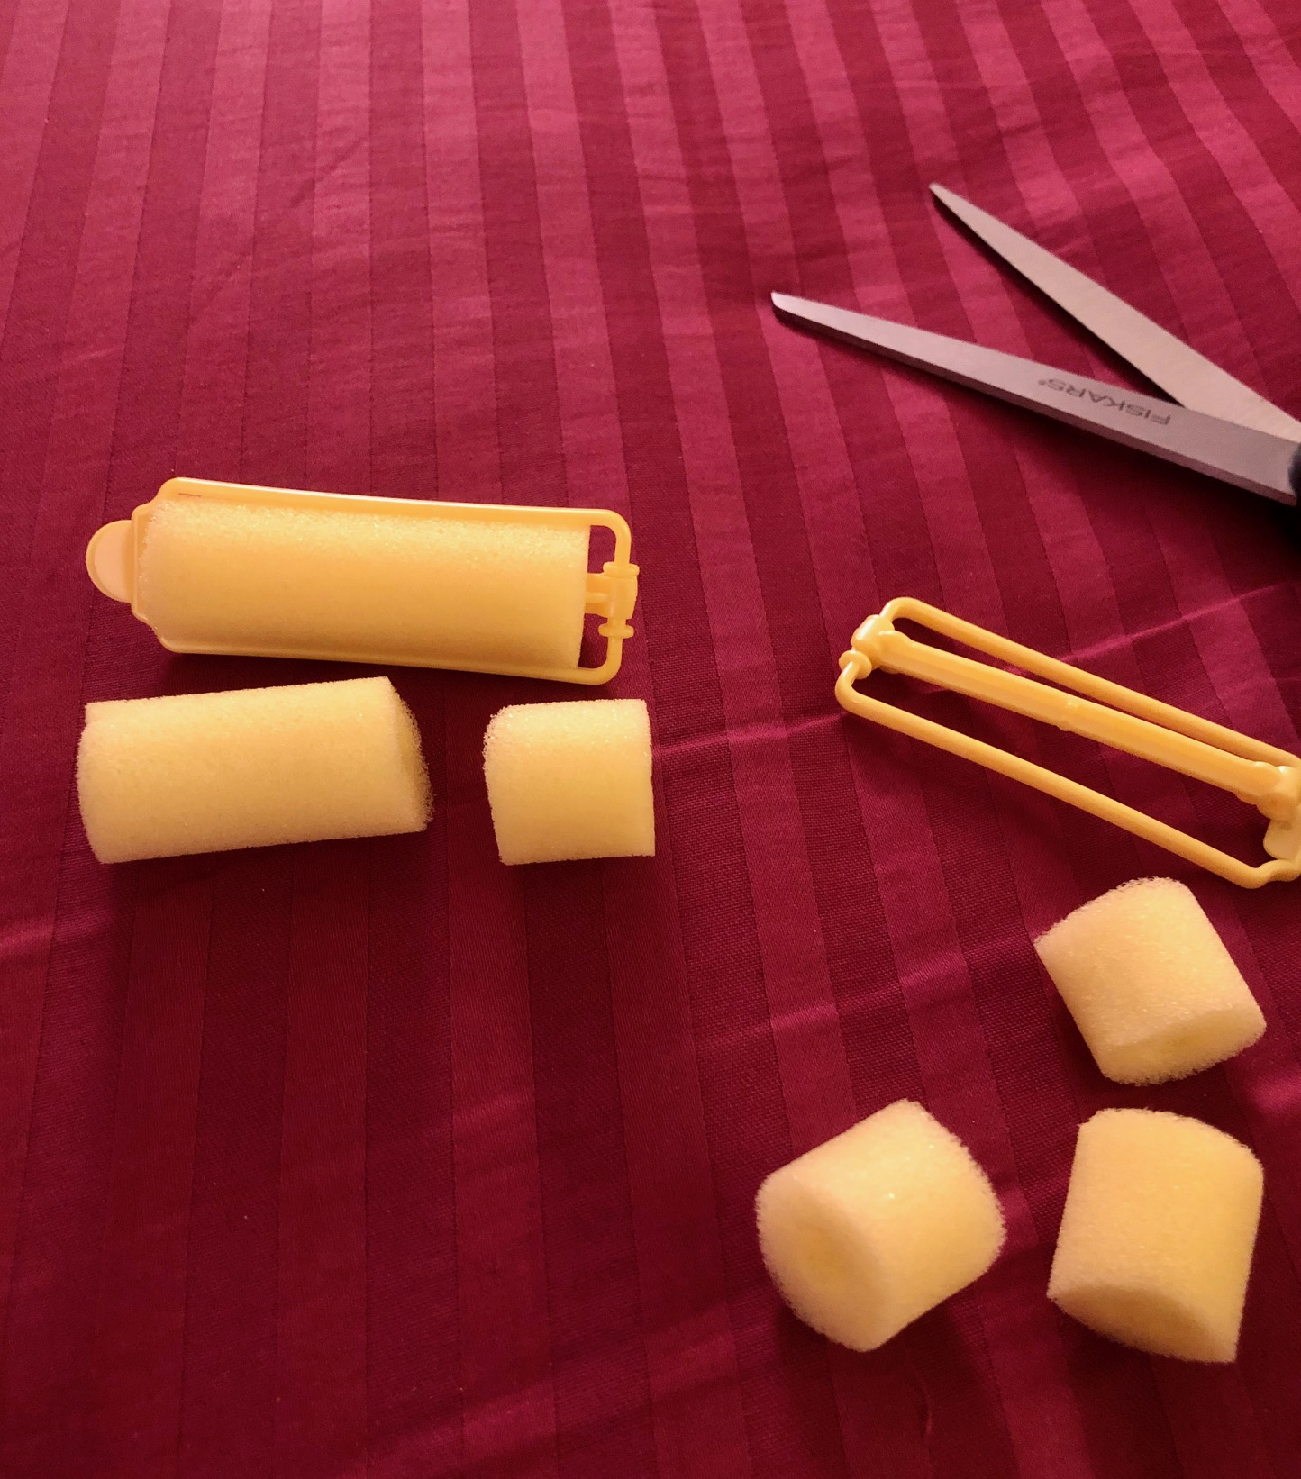

Curlers generally come in four sizes. Remove the plastic clip and cut in half for neck ruffs, and thirds for wrist ruffs.

Extra Large: 1 ¼” diameter, good for neck ruffs.
Large: 7/8” diameter, good for neck ruffs.
Medium: ¾” diameter, good for wrist ruffs or neck ruffs on children.
Small: ½” diameter, good for wrist ruffs on children.

Take a foam curler piece and wrap the ruffle around it to determine the size of the sett.

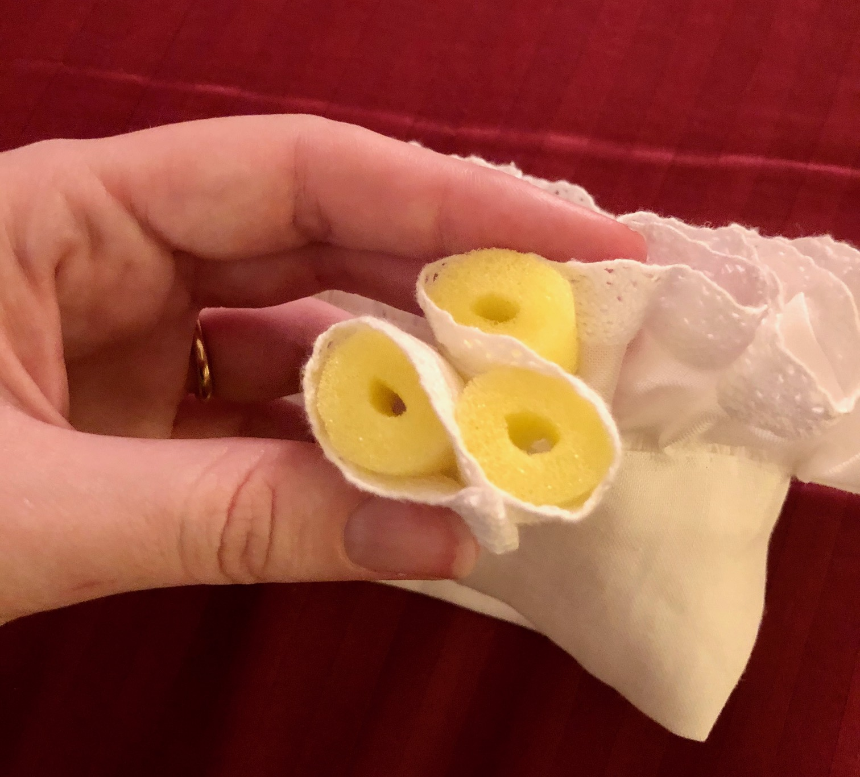

If you have lace, count the repeats of the lace pattern, and run a basting thread through.

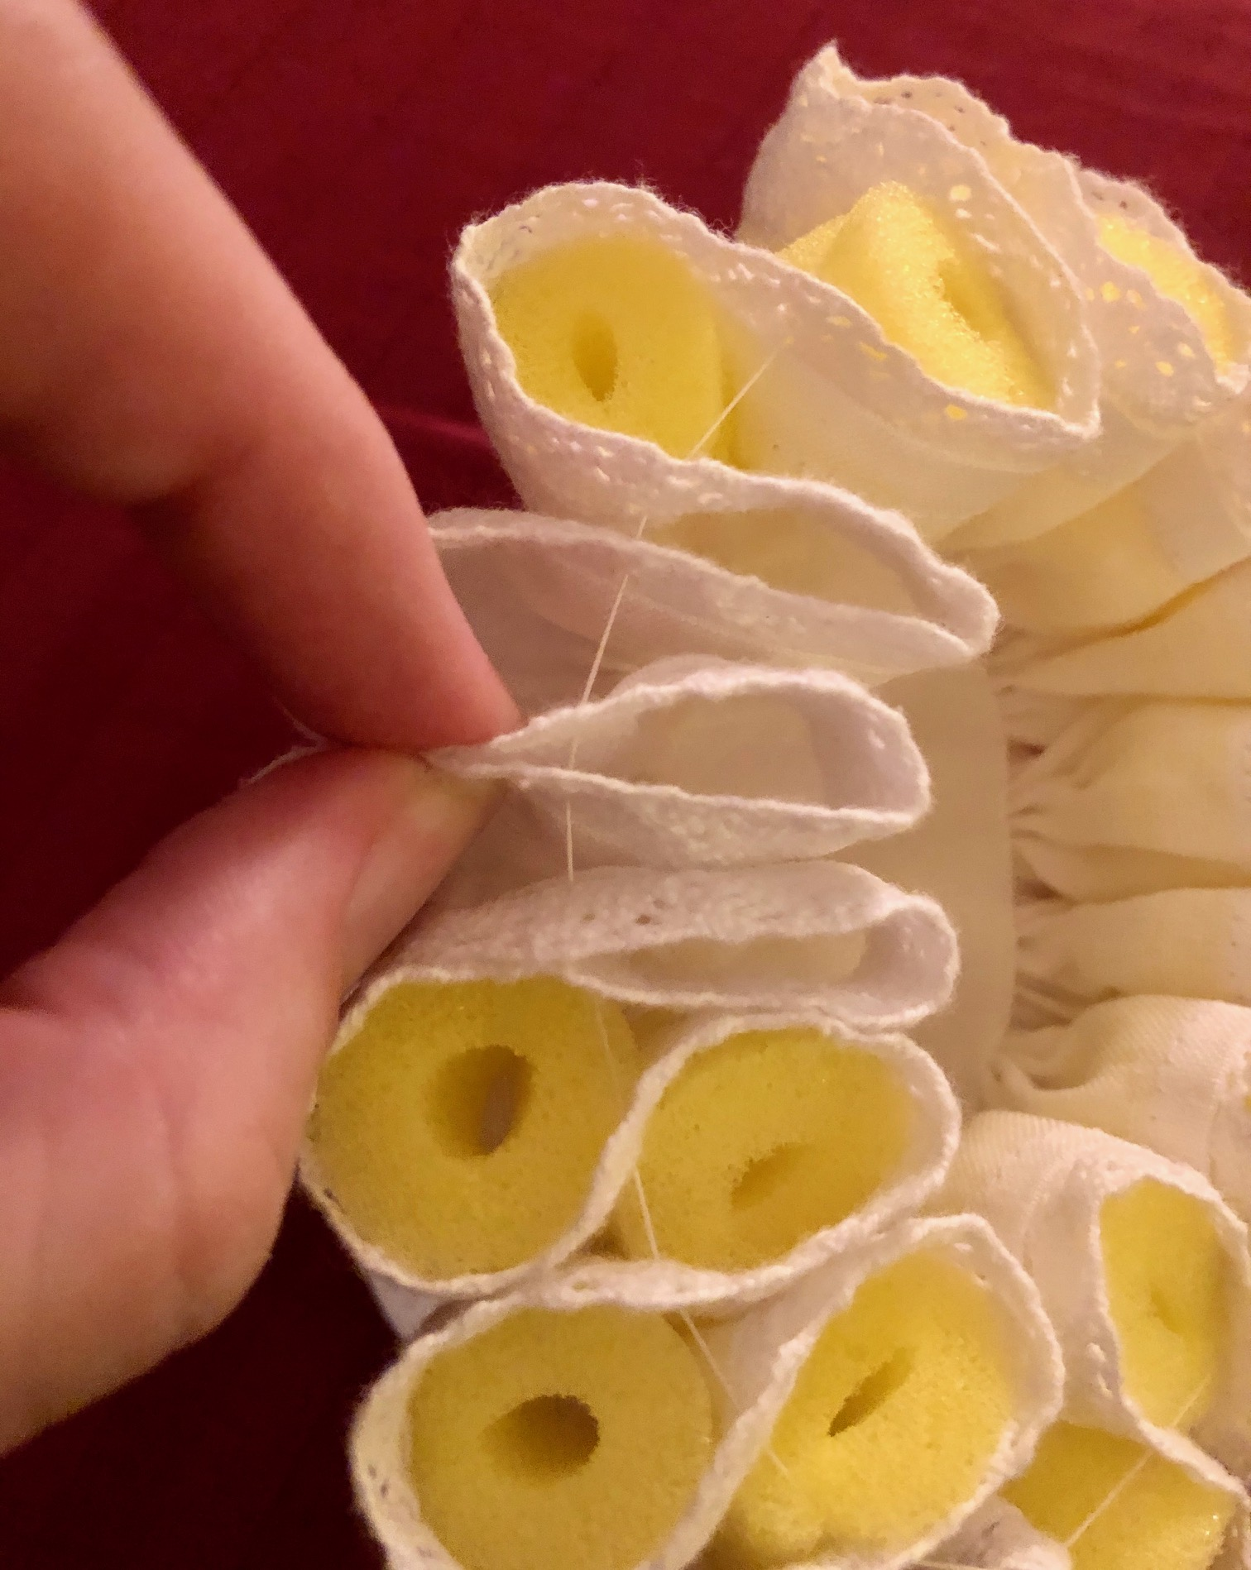

Continue counting and basting the rest of the ruff in a figure 8 pattern. If you end up with a little extra at the end, you can adjust the setts to take up the excess, or remove it and re-hem the front edge.

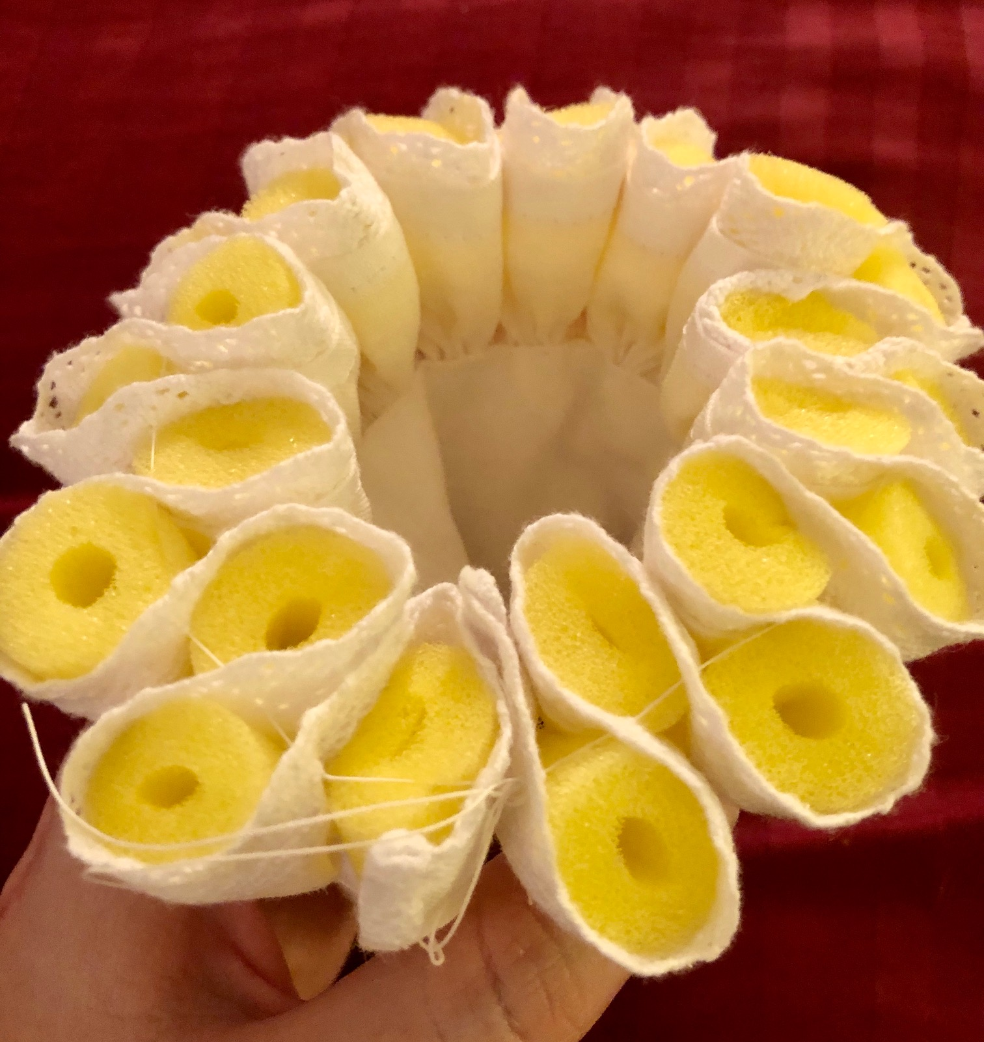

You want the center front to meet either in a figure 8, or to have two setts at the bottom (not the top!) for it to sit nicely around your neck.

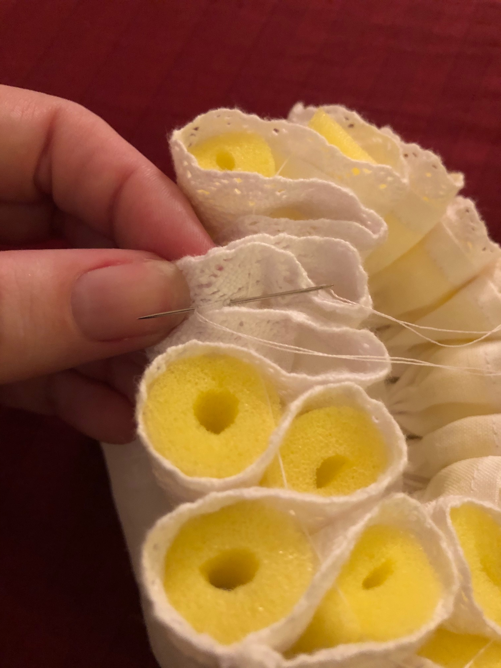

When you’re happy with the basted setts, tack the setts together at the top and bottom where they touch. Be careful not to attach them too high, otherwise it can pull the edges and make the ruff look triangular. You want a nice, candy ribbon curve.

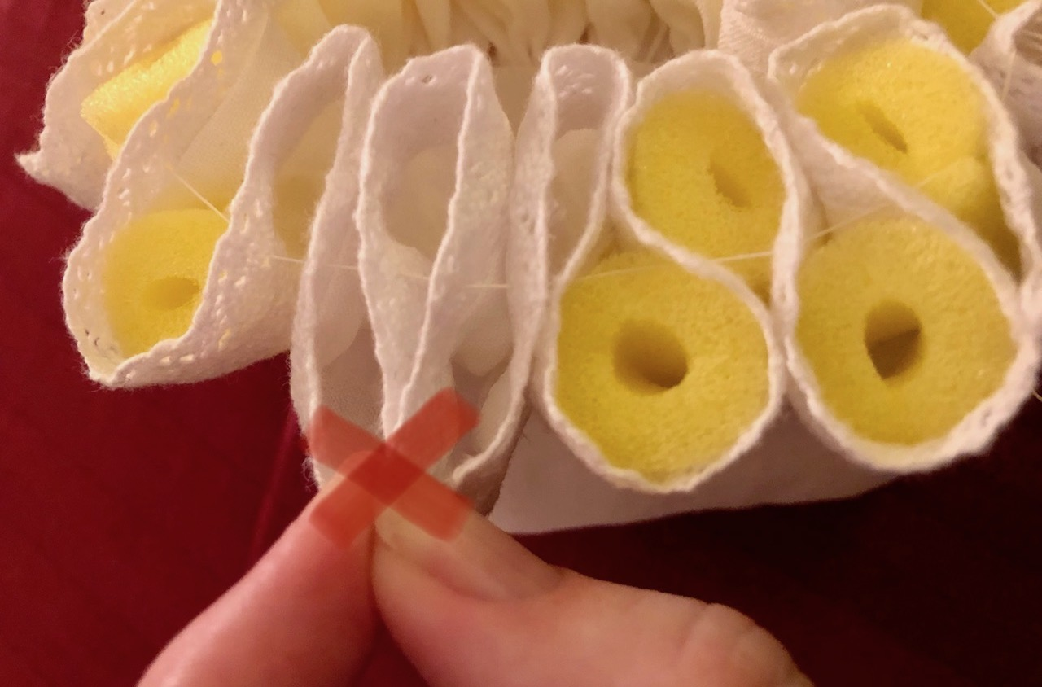

Pop the curlers into the tacked ruff. Spray the top and bottom of the ruff with heavy spray starch. Be generous! Fasten the closure and let the ruff dry in a circular shape. If you need the ruff in a hurry, you can use a hairdryer to speed up the drying time!

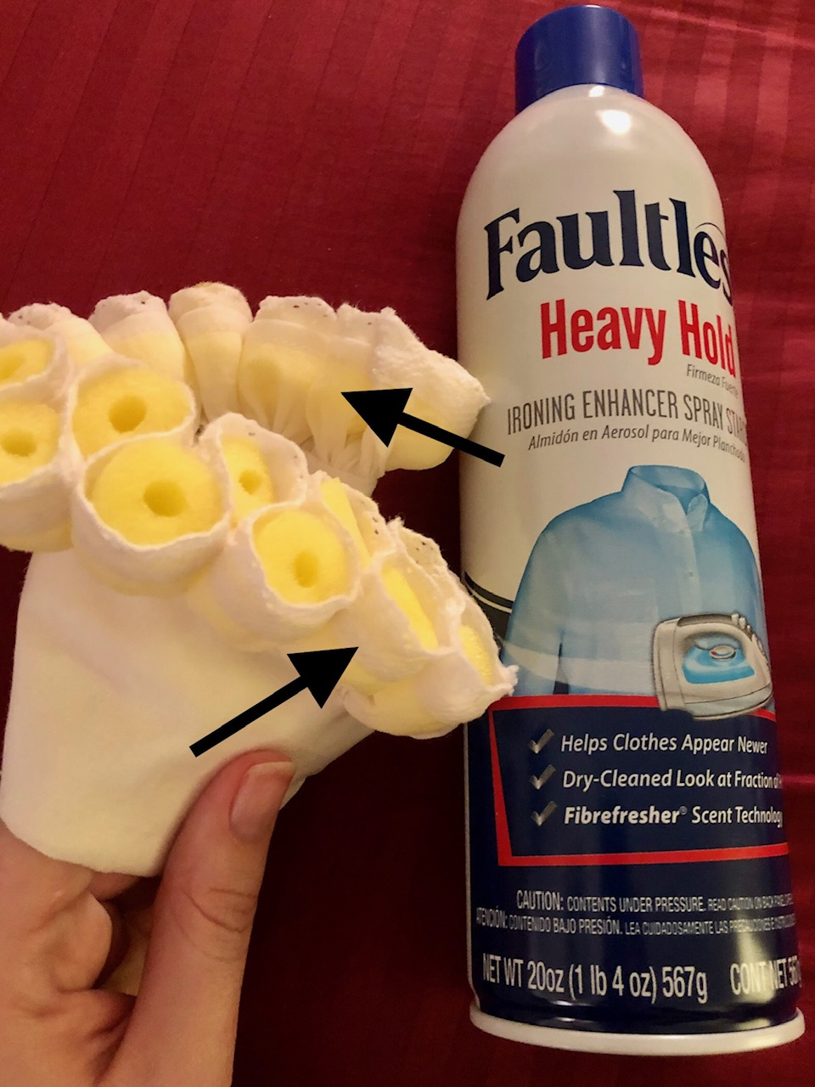

Leave the curlers in for storage or transport until you’re ready to wear your ruff. You can wash your ruff in the machine in a lingerie mesh bag in cold water. After the wash cycle, put the curlers into the damp ruff, spray with starch and let dry.

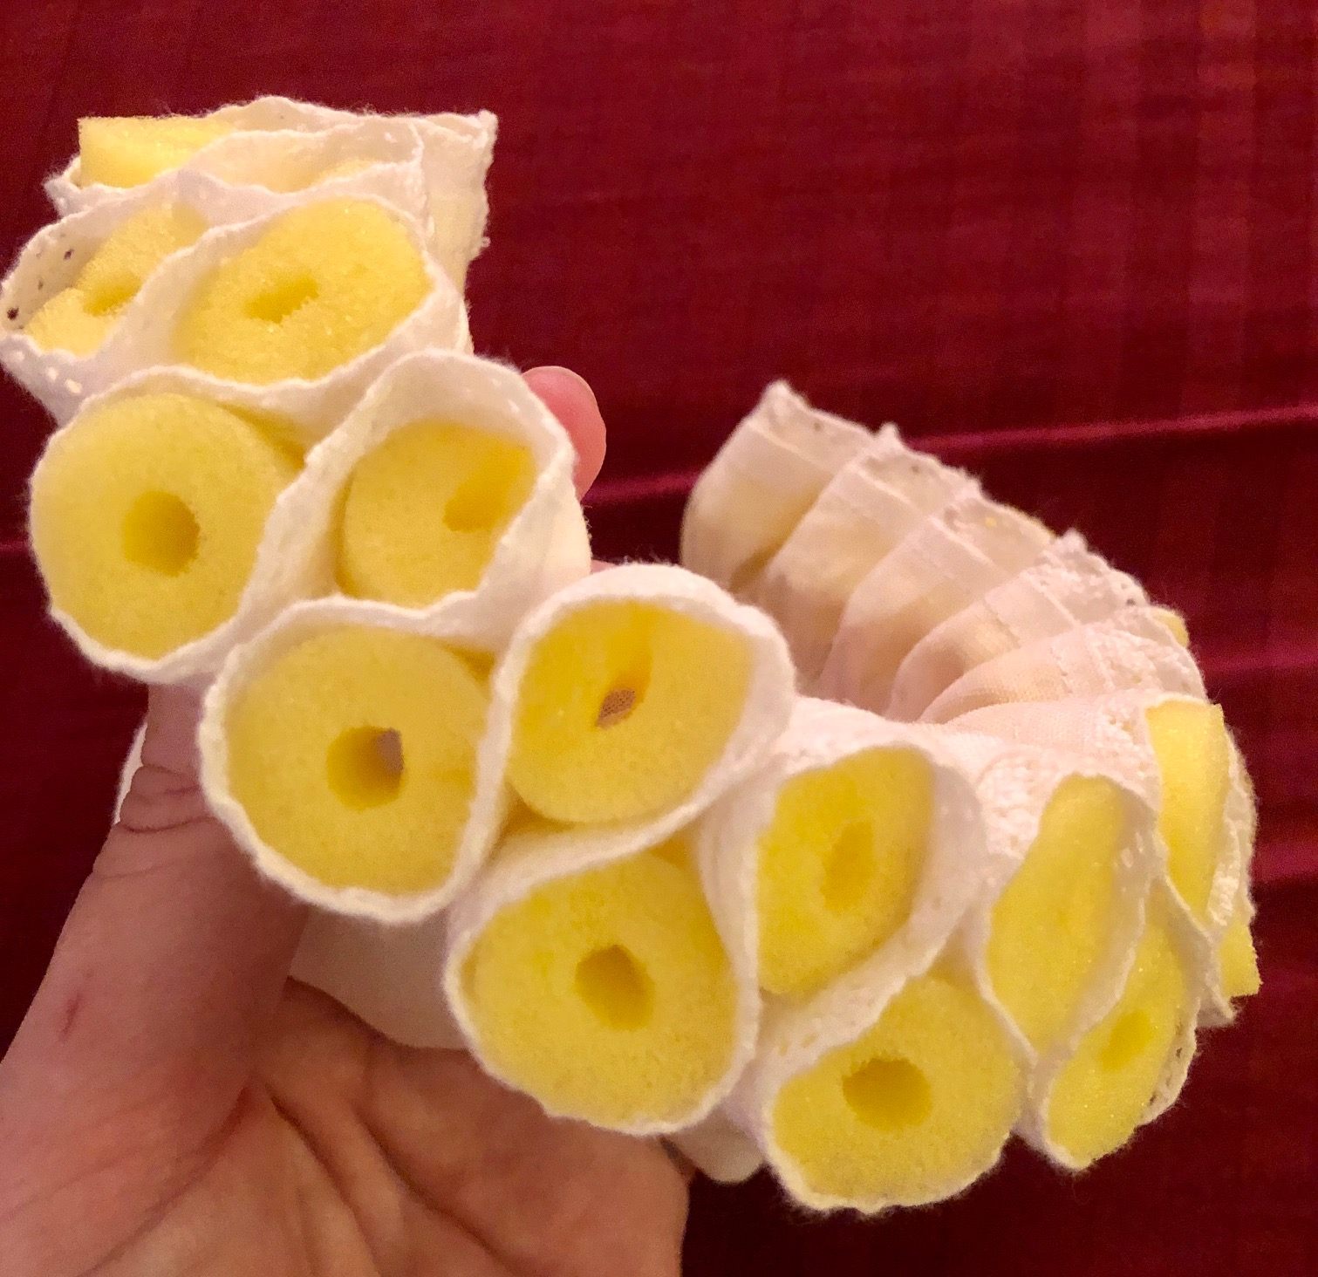

Sources from Noel Gieleghem

Books
Patterns of Fashion 4, The cut and construction of linen shirts, smocks, neckwear, headwear and accessories for men and women (c. 1540-1660) by Janet Arnold, Jenny Tiramani, and Santina M. Levey, published in late 2008, is the one-stop-shop for ruff information. My only caveat is to be wary of the instructions in the back about baking the starched ruff. I know of one ruff which has been broiled to a crisp using this technique due, I believe, to differences between European and American ovens. It is a truly great book and no one with an interest in the Elizabethan era should be without a copy. Buy it!

One of the most oft-quoted contemporary screeds against ruffs was written by Philip Stubbes in1583. His Anatomie of Abuses is online (http://www.elizabethancostume.net/stubbes.html).
However, as with all polemic, it should be taken with a grain of salt. As should most of the "facts" about ruffs found on the internet.

Jean Hunnisett's Period Costumes for Stage & Screen is also of interest, as it has both authentic and more theatrically appropriate methods.

Fabric
William Booth, Draper
2115 Ramada Drive
Racine, WI 53406
wmboothdraper.com
815/648-9048 (phone)
262/886-9133 (fax)
Nice, reasonably-priced linen.

Burnley and Trowbridge Co.
108 Druid Drive
Williamsburg, VA 23185
burnleyandtrowbridge.com
757/253-1644 (phone)
757/253-9120 (fax)
Talk to Angela. Great source for linen and other fabric as well.

Lace
Dharma Trading Company
1604 Fourth Street
San Rafael, CA 94901
dharmatrading.com
800/542-4227
A very good selection of Chinese cotton lace with incredibly fast mail order in the Bay Area.

Starch
Talas
330 Morgan Avenue
Brooklyn, NY 11211
talasonline.com
212/219-0770 (phone)
212/219-0735 (fax)
A source for rice and wheat starch. They make my (Jenn’s) favorite Zen Shofu wheat and archival rice products.

You may reach the instructors at: Jennifer Erlichman – jerlic@yahoo.com (PayPal jerlic@yahoo.com) and Christina Forst – xinainla@yahoo.com

